EXPERIMENT 2 : DDL Commands with Constraints – PRIMARY, FOREIGN KEY, UNIQUE, CHECK

OUTPUTS:
1)
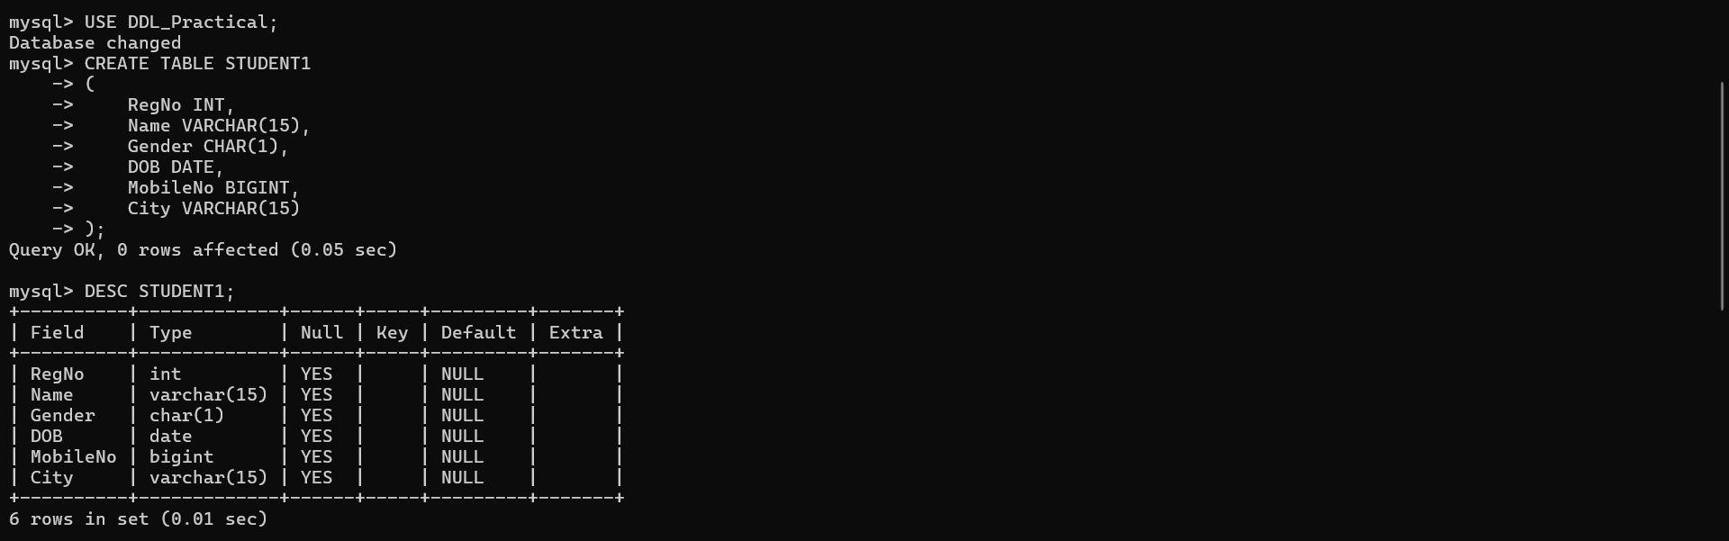

2)
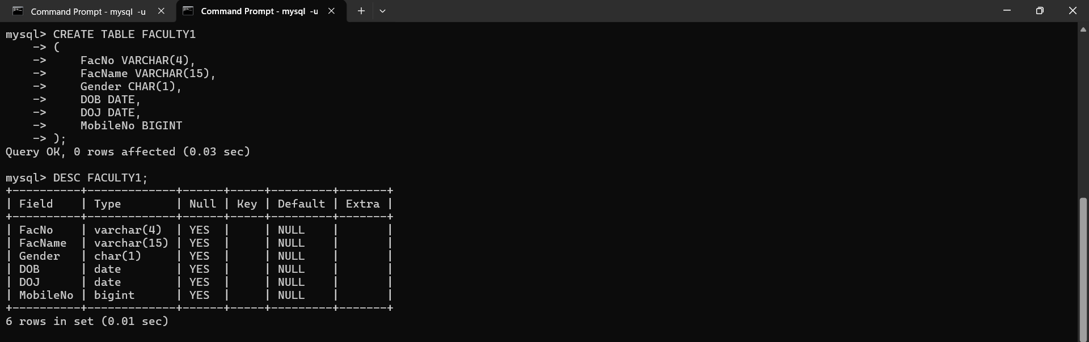

3)
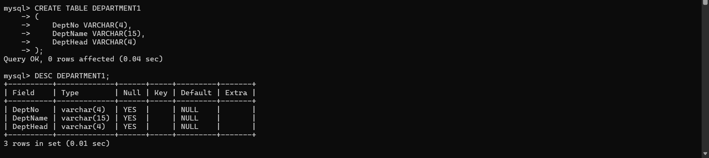

4)
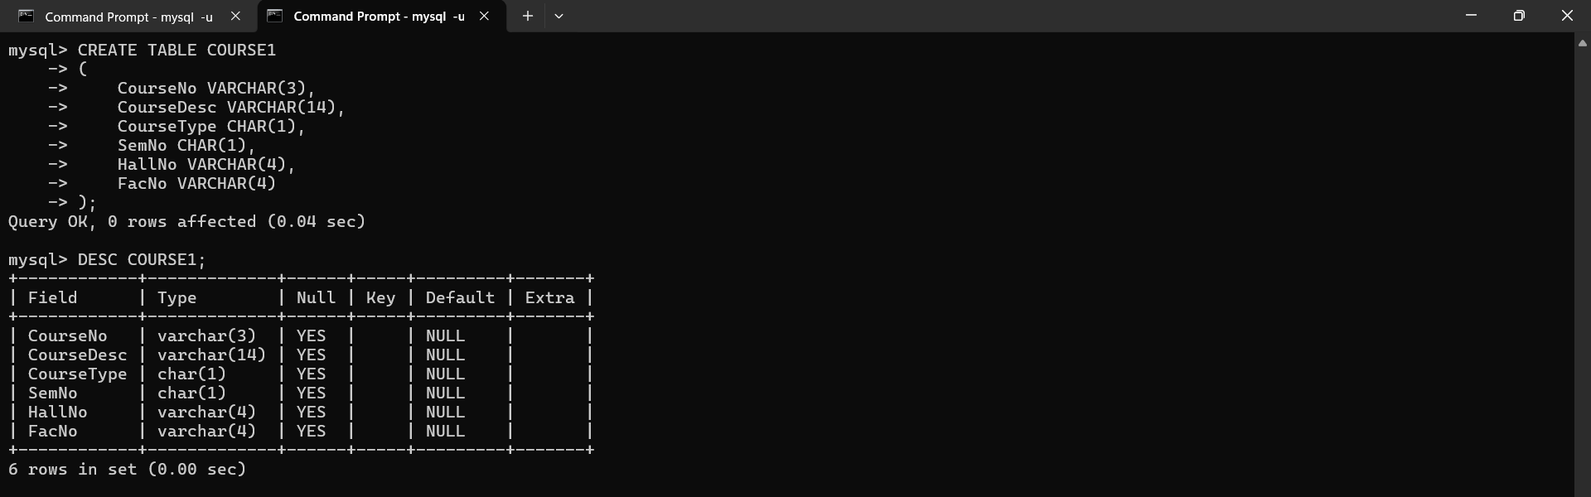

5)
